Distributed Database

* What is Data?

Data is a collection of facts, such as numbers, words, measurements, observations or just descriptions of things. Data is a collection of information.

* DBMS(Database Management System)

A database management system (or DBMS) is essentially nothing more than a computerized data-keeping system. Users of the system are given facilities to perform several kinds of operations on such a system for either manipulation of the data in the database or the management of the database structure itself.

* What is distributed database?

According to me distributed database is a database which stored on multiple servers for easily access with less loading time or transfer. Also distributed database is a concept on BLOCHCHAIN for security reason with the distributed database we can secure our records or contracts or any type data which don’t have to change that’s why we distribute the data so if any one can change the data so we can check with another copy of that data. Distributed database management system (DDBMS) is the software that manages the DDB, and provides an access mechanism that makes this distribution transparent to the user. Distributed database system (DDBS) is the integration of DDB and DDBMS. This integration is achieved through the merging the database and networking technologies together.

Or it can be described as, a system that runs on a collection of machines that do not have shared memory, yet looks to the user like a single machine.

A distributed database (DDB) is a collection of multiple, logically interrelated databases distributed over a computer network. A distributed database management system (distributed DBMS) is the software system that permits the management of the distributed database and makes the distribution transparent to the users.

The term distributed database system (DDBS) is typically used to refer to the combination of DDB and the distributed DBMS. Distributed DBMSs are similar to distributed file systems (see Distributed File Systems) in that both facilitate access to distributed data. However, there are important differences in structure and functionality, and these characterize a distributed database system:

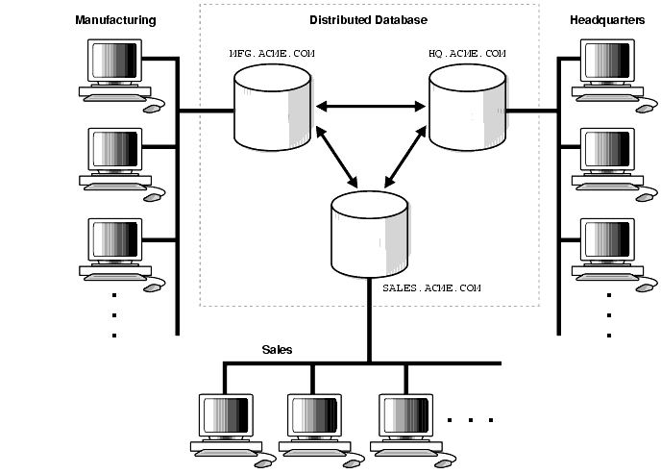

**Advantages of DDBMS**

* The database is easier to expand as it is already spread across multiple systems and it is not too complicated to add a system.
* The distributed database can have the data arranged according to different levels of transparency i.e. data with different transparency levels can be stored at different locations.
* The database can be stored according to the departmental information in an organization. In that case, it is easier for a organizational hierarchical access.
* there were a natural catastrophe such as fire or an earthquake all the data would not be destroyed it is stored at different locations.
* It is cheaper to create a network of systems containing a part of the database. This database can also be easily increased or decreased.
* Even if some of the data nodes go offline, the rest of the database can continue its normal functions.

## Disadvantages of DDBMS

* The distributed database is quite complex and it is difficult to make sure that a user gets a uniform view of the database because it is spread across multiple locations.
* This database is more expensive as it is complex and hence, difficult to maintain.
* It is difficult to provide security in a distributed database as the database needs to be secured at all the locations it is stored. Moreover, the infrastructure connecting all the nodes in a distributed database also needs to be secured.
* It is difficult to maintain data integrity in the distributed database because of its nature. There can also be data redundancy in the database as it is stored at multiple locations.
* The distributed database is complicated and it is difficult to find people with the necessary experience who can manage and maintain it.

